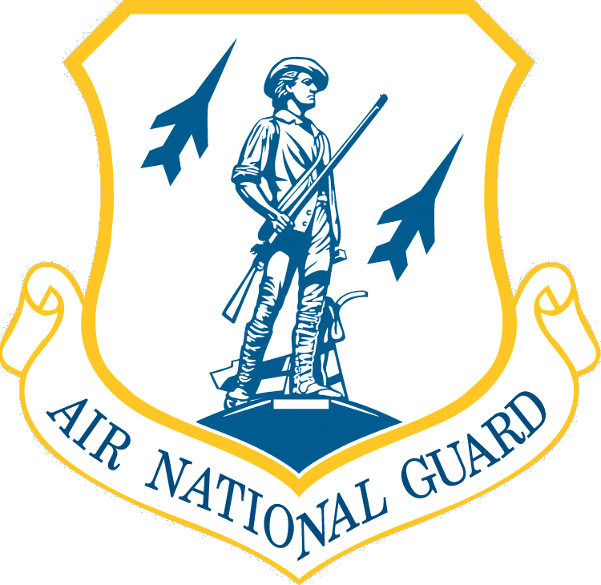
Indiana Air National Guard
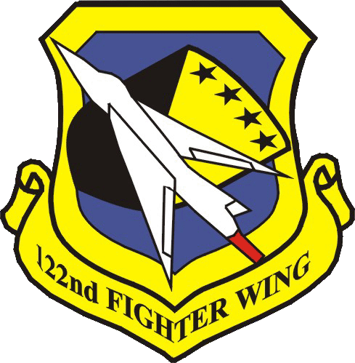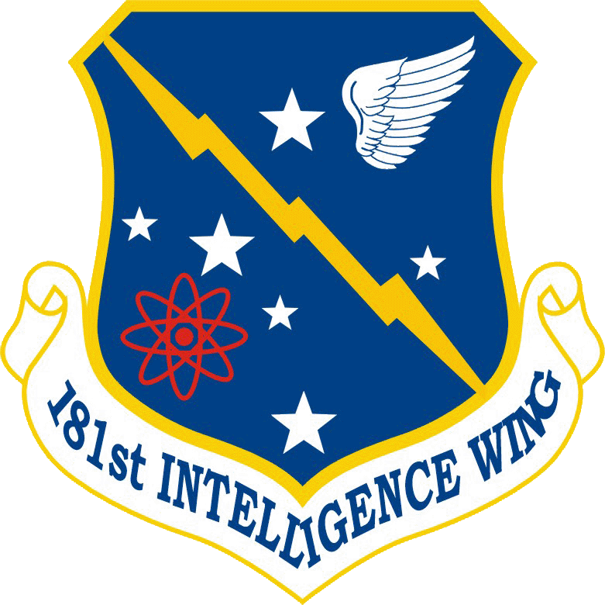
122nd FW and 181st IW
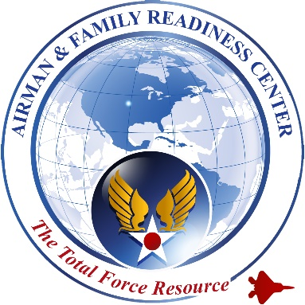
Airman and Family Readiness
Information and Resource Guide

Deployment Resource Guide
2020
Table of Contents

Contact Information………………………….……………………………..….. Page 3
Emergency Assistance and Notifications…………………...……..…………… Page 4-5
Local Agencies & Deployment/Veteran Assistance………..…….…..………… Page 5-6
Deployment Apps & Resources………………………………….……..............
Financial…………………………………………………………………….. Page 7-9
Career Resources……………………………………………………………. Page 9-10
Communication……………………………………………………………… Page 11
Health and Well-Being……………………………………………….……… Page 12-14
Preparing for Deployment…………………………………………………… Page 14
Marriage/Relationships……………………………………………………… Page 15
Dependents…………….……………………………………………………. Page 15-18
Household…………………………………………………………………… Page 18-19
Recreational…………………………………………………………………. Page 19-21
Miscellaneous Resources...……………………………………………....…… Page 21

Contact Information

AIRMAN AND FAMILY READINESS PROGRAM OFFICE

Connie Douthat
122nd FW
Building 780
Connie.s.douthat.civ@mail.mil
Office: (260) 478-3409
Cell: (260) 312-9980
https://www.facebook.com/122ndAirmanAndFamilyReadiness/

Margaret Amos
181st IW
Building 3
margaret.l.amos6.civ@mail.mil
Office: (812) 877-5545
Cell: (812) 249-1662
www.facebook.com/groups/181AFRPM

CHAPLAIN

Chaplain Michael Frese, Lt Col
122nd FW
Building 780
Michael.n.frese.mil@mail.mil
Office: (260) 478-3315

Chaplain Kent Lundy, Lt Col
181st IW
Building 3
Kent.a.lundy.mil@mail.mil
Office: (812) 877-5539

DIRECTOR OF PSYCHOLOGICAL HEALTH

Megan Ross, LSW
122nd FW
Building 780
megan.r.ross3.civ@mail.mil
Office: (260) 478-3733
Bill Little, LCSW
181st IW
Building 3
@mail.mil
Office: (812) 877-5726
FORCE SUPPORT CUSTOMER SERVICE

122nd FW
Building #780
(260) 478-3173
181st IW
Building # 18
(812) 877-5594

LEGAL OFFICE

Building 780
Office: (260) 478-3317

Building 18,
Office (812) 877-5385

FINANCE

Building 780
Office: (260) 478-3262
Building 18,
Office (812) 877-5204

SEXUAL ASSAULT RESPONSE COORDINATOR (SARC)

Lt Col Julie Burcroff Mary Walker
122nd FW 181st IW
Building #780 Building # 3
Office: 260-478-3327 SARC Cell: 812-264-4511
Emergency Assistance and Notifications

122 FW Airman & Family Readiness Office: Serves to support our deployers and their families with resources before, during, and following deployments. Contact us at (260) 478-3409. We are here for you!

American Red Cross: A military member or a member of their family needing to initiate an emergency message can go to redcross.org/HeroCareNetwork or call 877-272-7337. After a message is started online, a highly-trained emergency communication specialist will begin the emergency verification process required to deliver it to the military member’s command.

Indiana Red Cross Contact Information:
Greater Indianapolis Regional Headquarters
1510 N Meridian St
Indianapolis, IN 46202
Phone: (317) 684-1441

Central Chapter
Serving: Tippecanoe, Clinton, Howard, Tipton, Madison, Hamilton, Boone, Montgomery, Putnam, Hendricks, Henry, Hancock, Rush, Shelby, Johnson, and Morgan Counties
2750 N 9th St. Ste. G
Lafayette, IN 47904
Phone: (765) 742-6975

Northeast Chapter
Serving: LaGrange, Steuben, Noble, DeKalb, Kosciusko,Whitley, Allen, Wabash, Miami, Grant, Wells, Adams, Blackford, Jay, Delaware, Randolph and Huntington Counties
1212 E. California Road
Fort Wayne, IN 46825
(260) 484-9336

Southeast Chapter
Serving: Wayne, Union, Fayette, Franklin, Decatur, Ripley, Jennings, Switzerland, Jefferson, Bartholomew, Jackson, Scott, Brown, Monroe, Lawrence, Orange, and Washington Counties
1600 W. 3rd St.
Bloomington, IN 47404
(812) 332-7292

Northwest Chapter
Serving: Lake, Porter, LaPorte, St. Joseph, Elkhart, Marshall, Starke, Jasper, Newton, Pulaski, Fulton, White, Cass, Carroll, Benton, Warren
791 E. 83rd Ave.
Merrillville, IN 46410
(219) 756-5360

Southwest Chapter
Serving: Knox, Vigo, Daviess, Gibson, Pike, Dubois, Posey, Vanderburgh, Warrick, Spencer, Perry, Sullivan, Crawford, Martin, Greene, Owen, Clay, Fountain and Vermillion Counties
29 Stockwell Rd.
Evansville, IN 47714
(812) 471-7200

Red Cross Hero Care App: Offers confidential services to all veterans and their families by connecting them with local, state and national resources worldwide. Compatible on any Apple or Android device.

Suicide Prevention/Veteran Crisis Line - Free to all Service members and Veterans, even if you are not registered with the U.S. Department of Veterans Affairs (VA) or enrolled in VA health care. 1-800-273-8255 press 1

Local Agencies & Deployment/Veterans Assistance

Air Force Aid Society: The Air Force Aid Society (AFAS) is a non-profit organization that assists active duty members, retirees, and families during emergencies. ANG members can use this assistance when on active duty order for more than 30 days. They give interest-free loans or grants for basic needs to find out more about AFAS, you can visit their website at www.afas.org.

Air Force Casualty Assistance: Provides information on Casualty Assistance Representatives and Survivor Benefit plans. https://www.afpc.af.mil/Benefits-and-Entitlements/Casualty-Operations/

Air Force Sergeants Association: Represents the professional and personal interests of all enlisted grades of Air Force Active Duty, ANG, and AFRC, retired, veteran, and family members. www.afsahq.org/ (800) 638-0594

Air Force Services: Provides mission sustaining combat support and community service to Airmen and their families every day at deployed and home station locations. https://cs2.eis.af.mil/sites/10042

Survivor Assistance Program: Provides resources for seriously wounded, ill, and injured, their families, and families of the fallen. https://www.militaryoncesource.mil/survivor-casualty-assistance-resources 1-800-342-9647

Armed Services YMCA: Provides support services to military service members and their families for more than 140 years. The essential programs are childcare, hospital assistance, spouse support services, food services, computer training classes, health and wellness services, and holiday meals. Find a local branch at http://www.asymca.org

Fisher House: Donates "comfort homes" to allow family members to be close to a loved one during the hospitalization for an unexpected illness, disease, or injury. There is at least one Fisher House at every major military medical center. Phone: (888) 294-8560 https://www.fisherhouse.org/

H.E.R.O.E.S Care: What is H.E.R.O.E.S. Care? H.E.R.O.E.S. Care is a collaborative effort among well-established non-governmental organizations (NGOs) designed to provide complete and proactive support for members of all branches of the military and their families through pre-deployment, deployment, family reintegration and post-deployment. To register for support during and after your deployment, go to https://www92.safesecureweb.com/ohfmohc/Hregistration1.asp
Indiana Department of Veterans Affairs: In addition to the federal benefits available, the state of Indiana has a number of its own benefits. To find out more visit: https://www.in.gov/dva/
If you would like assistance in navigating the complex web of services and benefits, go to: https://www.in.gov/dva/2370.htm to find a Veteran Service Officer that can assist you.
To list a few of the Indiana State benefits:
- Tax Deductions
- Tuition and Fee Exemption
- Disabled Hoosier Veteran License Plates
- Employment Assistance
- Resident Veteran Hunting & Fishing License
- Golden Hoosier Passport
- High School Diploma Program for WWI, WWII, Korea, and Vietnam Veterans

Military OneSource: Provides access to web-based Department of Defense resources for the Total Force and their families. It is a virtual extension of installation services. This website has numerous resources available to guide and help you and your family cope with the transition and stressors of deployment. www.militaryonesource.com or phone: (800) 342-9647

Military Officers Association of America: The “leading voice on compensation and benefit matters for all members of the military community.” The association provides expert advice and guidance to its members. http://www.moaa.org/ or phone: (800) 234-6622

National Military Family Association: Represents the interests of family members of the uniformed services. Activities revolve around programs to educate the public, the military community, and Congress on the rights and benefits of military families.
https://www.militaryfamily.org/ or phone: (703) 931-6632

United States Department of Veterans Affairs: Principal advocate for America's Veterans; ensuring that they receive medical care, benefits, social support, and lasting memorials promoting the health, welfare, and dignity of all Veterans in recognition of their service to this Nation. http://www.va.gov/ VA Benefits: (800) 827-1000, Education (GI Bill): (888) 442-4551, Health Care Benefits: (877) 222-8387

United Service Organizations (USO): The USO is a private, nonprofit organization whose mission is to support the troops by providing morale, welfare and recreation-type services to our men and women in uniform. http://www.uso.org/ or phone: (888) 484-3876

USA4 Military Families: Provides online information about the ten Key Quality of Life issues. The USA4 Military Families initiative works through the DoD-State Liaison Office (DSLO) to engage and educate state policymakers, not-for-profit associations, concerned business interests, and other state leaders about the needs of military members and their families. https://statepolicy.militaryonesource.mil/

2-1-1: Resource for emotional assistance, day-to-day challenges, and confidential services such as to combat homelessness or locate food service programs. www.veteransconnect211.com
Financial Resources

Automatic Federal Tax Filing Extension: Armed Forces’ Tax Guide https://www.irs.gov/publications/p3/index.html

BRS Standalone Calculator: https://militarypay.defense.gov/Calculators/Blended-Retirement-System-Standalone-Calculator/

DoD Savings Deposit Program (SDP): The DoD Savings Deposit Program (SDP) was established to provide members of the uniformed services serving in a designated combat zone the opportunity to build their financial savings. If you are serving in an SDP-eligible combat zone, you can start your SDP account once you’ve been deployed for a minimum of 30 consecutive days or at least one day in each of three consecutive months. To learn more, go to http://www.dfas.mil/dfas/militarymembers/payentitlements/sdp.html
Financial Resource Guide: Each of the resources provided below has been vetted for relevance, organization, ease of use, and resource content. All resources listed are also free to use; however, some of the online resources may require registration to access some of their features. https://www.yellowribbon.mil/cms/financial-resource-guide/

INGRF Grant: Indiana National Guard Relief Fund is available to provide emergency assistance and relief to members of the Indiana National Guard and their families who are undergoing periods of personal or financial distress due to a period of mobilization or other military duty. Applicants can be awarded up to $5,000 if not deployed, and $10,000 if deployed. Please visit the website or your local Airman & Family Readiness office for application. https://www.in.ng.mil/

MFRF Grant: Military Family Relief Fund Grant is designed to assist military families that are experiencing financial hardship. The service member must be serving honorably or received an honorable discharge. Members may be eligible for the fund if they have at least 12-months of qualifying military service on ther DD 214. This is a one-time emergency grant for up to $2,500.00. Please visit the website or go to your Airman & Family Readiness office for application. www.in.gov/dva

National Guard Veterans Project: The National Guard Veterans Project is funded by the Sheehan Family Foundation and is operated in partnership with Aspire Indiana. The purpose of this project is to resolve housing crisis for National Guard Service Members who are homeless or facing eviction in Hamilton County. The project will award up to $1,000 per household for security deposits, rental assistance, utility deposits and past-due rent or utilities. Service Members may access this program more than once. Assistance is not to exceed $1,000 per household. 855-896-4345 nationalguardproject@intecare.org

NIBCC Grant: Northeast Indiana Base Community Council, Inc. grant is available to service members who are not deployed but living or assigned to a unit in NE Indiana. The grant is for up to $650 and is a one-time only grant. Please see your Airman & Family Readiness office for application.

Office of Financial Readiness: Resources, education and support for every stage of financial readiness- whether you’re just getting started learning about finances, interested in tweaking your current plan, or ready to jump in with both feet. Our goal is to foster a financially secure and mission-ready force with every military family living their best life today and in the future. Our door is always open, so visit us here often and see what’s new! https://finred.usalearning.gov/

Operation Homefront (OHF): Provides emergency financial and other assistance to the families of our service members and wounded warriors. http://www.operationhomefront.org/

Pan Foundation: High deductables and co-pays shouldn’t keep people with life-threatening, chronic and rare disease from getting the treatment they need. PAN uses the donations of caring individuals and corporations to offer the fastest, most dependable way for patients to pay their out-of-pocket costs. Because when the unexpected happens, all you should have to focus on is getting better. https://panfoundation.org/

Patient Services Inc: A non-profit that provides financial support and guidance for qualified patients with specific, rare chronic diseases. https://www.Patientservicesinc.org

ThanksUSA: A non-partisan, charitable effort to providing need-based college, technical and vocational school scholarships and pathways to employment for children and spouses of our troops. http://www.thanksusa.org

The Assistance Fund: The Assistance Fund (TAF) is an independent 501©(3) nonprofit organization dedicated to providing financial assistance to patients with serious and chronic diseases. TAF has programs for copay assistance, insurance premiums and incidentals and health care expenses. https://tafcares.org/

And, just a piece of advice, if they are facing a very expensive drug and
cannot find funding available for assistance in paying for that drug, call
the pharmaceutical company directly, explain that there is no current
funding available and they might be able to provide the drug at no cost to
the patient while the patient waits for funding to become available.

Unmet Needs: Provides basic life needs such as: mortgage and rent, home and auto repairs, insurance, utilities, food and clothing. National Guard and Reserve members must be either active duty or discharged from active duty within the last 36 months. The active duty must be other than Basic Training, Annual Training and monthly drill. https://www.vfw.org/assistance/financial-grants or 1-866-789-6333

SGLI: Airmen don't have to wait for the automated "birth month" email. They can update their coverages at any time and as often as they like by signing into milConnect https://www.dmdc.osd.mil/milconnect/ Service members' Online Election System (SOES). SOES enables Airmen to make automated Service members' Group Life Insurance and Family SGLI coverage/beneficiary elections 24/7, 365 days a year.

Deploying Service members: Consider an active duty alert: The Federal Trade Commission (FTC) staff suggest your list include placing an active duty alert on your credit reports to help minimize your risk of identity theft. An active duty alert on your credit report means businesses must take extra steps before granting credit in your name. Active duty alerts last for one year and can be renewed to match your deployment period.
To place an active duty alert on your report, contact the fraud department of one credit reporting company; they must contact the other two.
- Equifax: 1-800-548-7878 or www.equifax.com
- Experian: 1-888-397-3742 or www.experian.com
- TransUnion: 1-855-681-3196 or www.transunion.com

The credit reporting companies also will take your name off their marketing lists for prescreened credit card offers for two years, unless you ask them to add you back onto the list.

Career Resources

Distance Learning - User-driven and scenario-based modules and activities for individual training. Modules include videos, quizzes and dynamic learning for first-time users or those in need of a refresher. http://www.yellowribbon.mil/yrrp/distance-learning-update.html
Employment Support of the Guard and Reserve (ESGR) promotes cooperation and understanding between Reserve component service members and their civilian employers and to assist in the resolution of conflicts arising from an employee’s military commitment. http://www.esgr.mil

O*Net Online: Great resource tool for building resumes and finding occupations: https://www.onetonline.org/

The Military Spouse Career Advancement Accounts Program (MyCAA) is a career development and employment assistance program. MyCAA helps military spouses pursue licenses, certificates, certifications, or Associate's Degrees necessary for gainful employment in high demand, high growth Portable Career Fields and Occupations. https://mycaa.militaryonesource.mil/mycaa

eBenefits: Veterans Employment Center offers resume writing assistance and job searches. http://www.ebenefits.va.gov

Employment Resource Guide: Each of the resources provided has been vetted for relevance, organization, ease of use, and resource content. All resources listed are also free to use; however, some of the online resources may require registration to access some of their features. http://www.yellowribbon.mil/cms/employment-resource-guide/

Employee Assistance Program (EAP) - A voluntary service that provides assessment, counseling, referral, management consultation, and coaching services to Federal employees and agencies throughout the United States. For assistance, call 1-800-222-0364 or got to http://foh4you.com

Air Force Credentialing Opportunities On-Line (AF COOL): AF COOL Program is designed to help airmen identify and complete AFSC mapped licenses and/or certifications, which will help them advance their careers and later compete in the civilian workforce. You must be an enlisted member at the rank of E-3 and above, who possess a 5-skill level in the approved AFSC mapped credential. Additional leadership and Management credentialing opportunities are available to SNCOs. A maximum amount is available to each airmen over the course of his/her career. For more information, visit the AF COOL website: https://afvec.us.af.mil/afvec/Public/COOL/

Soldier for Life-Transition Assistance Program: The Soldier for Life – Transition Assistance Program (SFL-TAP) has launched a new online magazine specifically for transitioning soldiers. Be one of the first to read "Hire a Soldier", featuring Sergeant Major of the Army Daniel Dailey on the cover and his tips for a successful transition. Plus, read stories from transitioning soldiers, gain tips and advice for transition, learn how to navigate the online world of job searching, as well as read about networking and personal branding. http://www.armyg1.army.mil/docs/Hire_a_Soldier_Magazine.pdf

Transitioning Resource: This site is dedicated to helping our military members successfully return to civilian life and find meaningful employment. We are veterans that share insights to compliment the military Transition Assistance Program (TAP), Soldier for Life (SFL), SFL-TAP, Army Caree and Alumni (ACAP) and Transition GPS (T-GPS) programs. We are not affiliated with the Department of Defense (DoD), military services (Army, Navy, Air Force, Marines, Coast Guard), Hiring our Heroes (HOH), HireHeroes, HireOurHeroes, or Hiring Heroes Program. Our goal is to serve those who served us by providing information to help guide transition related decisions. https://www.military-transition.org/
DOD SkillBridge: Basically, this is a program that allows transitioning service members (whether they are retiring or separating) to spend their last 6 months in uniform doing civilian job and employment training, including apprenticeships and internships.
SkillBridge is training for a civilian job that you receive while still employed by the DOD. The training must provide eligible service members with an experience to acquire employment skills, knowledge, or abilities to assist them with job opportunities in the civilian sector. There must be a high probability of post-service employment with the provider (the company you work with during SkillBridge) or any other employer. Enrollment has to be provided at no cost or minimal cost to eligible service members.
For more information visit: https://dodskillbridge.com

Communication Resources

Bob Hope Legacy Reading Program USO Unites: A way to bring military families together, the USO provides the opportunity for Service Members and Military children to record themselves reading a book and have that recording and book mailed to their service or child. https://bobhope.uso.org/programs/bob-hope-legacy-reading-program In Indiana, outreach to USO Indiana (www.indiana.uso.org) 317-991-1073 indianamainoffice@uso.org to coordinate a location and time to record your story time.

United Through Reading Program: United Through Reading connects military families through the read-aloud experience, and we are working to close the gap so that every military child has the opportunity for bedtime stories. Visit a United Through Reading Story Station around the world, or download the United Through Reading App available on both Apple and Android devices. For more information, please visit http://www.unitedthroughreading.org/.

The following are available apps used to text, call, and send videos over a Wi-Fi connection. Airman & Family Readiness does not endorse any of these, just providing information on available apps out there to help communicate with loved ones back home.

Loklok App- Replaces the Android Phone’s lock screen with a “synchronized whiteboard” that allows you to leave notes and drawings directly on your friends’ lock screens. That means, unlike traditional messaging apps, you don’t have to unlock your phone and launch an app to chat with your friends. You just take out your phone and start drawing. Compatible with Android.

Marco Polo: Combines the best of texting, social media and video chats- all in one private, easy to use app. Compatible with Android and iOS.

Signal Messenger: A completely open source, free, secure, and private instant messaging platform, just like WhatsApp. Like any other modern instant messaging service, Signal supports text, images, videos, voice and video calls, and documents.

Viber Messenger: A free download app that allows users to make free calls, send texts, pictures and video messages to other Viber users. Compatible with iOS and Android.

WhatsApp: A freeware, cross-platform messaging and Voice over IP service owned by Facebook, Inc. It allows users to send text messages and voice messages, make voice and video calls, and share images, documents, user locations, and other media.

Wickr Me: Instant messaging app that allows users to exchange end-to-end encrypted and content-expiring messages, including photos, videos, and file attachments and place end-to-end encrypted video conference calls. The software is available for iOS, Android, Mac, Windows 10, and Linux operating systems.

Health & Well-Being Resources

TRICARE
When a member changes their Personnel Categories within DEERS, they will need to contact TRICARE, to reestablish your eligibility with either TRICARE Prime or Select otherwise the member and their family will revert to Direct Care. TRICARE Prime/Select is NO longer an automatic election. When there is a "category change" processed in DEERs, the person must re-enroll in PRIME or Select within 90 days of the change. DEERS doesn't roll their status over.

Active Duty Medical Care: http://tricare.mil/Plans/Eligibility/NGRMandFamilies
- Before your orders begin: Pre-Activation TRICARE eligibility begins on the date your orders are issued or 180 days before you report to active duty, whichever is later. During this "pre-activation" period, you qualify for the same benefits as you have when you're activated.

- While on orders: When you're activated or ordered to active service for more than 30 consecutive days, you become eligible for the same health and dental benefits as active duty service members. You will need to enroll in one of the Prime options when you arrive at your final duty station. Family members are eligible for Tricare as active duty family members as well.

- After your orders are completed: When deactivated, you qualify for the Transitional Assistance Management Program (TAMP) for 180 days, but you must request this. TAMP coverage begins the first day after your active duty orders end and your family members are covered, too. During the TAMP period, you will need to enroll in one of the Prime options.

For questions related to DEERS, please call 122nd FW FSS Customer Service: (260)-478-3173.

Nurse Advice Line: Free Military Health System Nurse Advice Line: 1-800-TRICARE (874-2273), Option 1
The Nurse Advice Line is available to all TRICARE beneficiaries in the U.S., except those enrolled in US Family Health Plan. You can call the Nurse Advice Line 24/7, at no cost to you, to talk to a registered nurse who can answer your urgent care questions, give you professional health care advice, help you find a doctor, and/or schedule next-day appointments at military hospitals and clinics.

If you have an emergency, call 911 or go to the emergency room. The hospital department that provides emergency services to patients who need immediate medical attention.
You DO NOT have to call TRICARE first in the event of an emergency!

Do you have other health insurance in addition to TRICARE, such as Medicare or an employer-sponsored health insurance? You can call TRICARE for help, but if you need to see a doctor, remember:
- You must follow the rules of your other health insurance plan first.
- Your other health insurance is the primary payer.
- If we help you find a doctor make sure they're in your other plan’s network or your care may not be covered

Counseling Resources
Military service members and their families have many options for counseling services, and many are offered free of charge. If you are considering counseling, be sure to look into these resources:
- 122nd FW Director of Psychological Health (DPH):
Megan Ross
- (260) 478-3733
- Megan.r.ross3.civ@mail.mil

- Indiana Department of Veteran Affairs-Peer 2 Peer support, Enrichment groups, and Alternative Therapy www.in.gov/dva/2989.htm

- PTSD Coach - A mobile application that provides information about PTSD, self-assessment and symptom management tools and resources available for help in dealing with post trauma effects. The app is free and can be used on iPhone or Android devices. To download, visit www.ptsd.va.gov/public/materials/apps/PTSDCoach.asp

- Military OneSource: 1-800-342-9647 or www.militaryonesource.mil. Provides up to twelve nonclinical sessions per person, per issue, per year, with a licensed professional. These personal sessions are available face-to-face, by telephone, or online.

- Military Family Life Consultant (MFLC):
On Demand availability for UTA and Yellow Ribbon Events through Military OneSource
  - Adult MFLC
  - Youth MFLC

- TRICARE allows free counseling with a provider of choice under certain circumstances. Call 1-844-653-4061 or check eligibility depending on plan/status at https://tricare.mil/dental/

- Military Crisis Line: Free to all Service members, including members of the National Guard and Reserve, and Veterans, even if you are not registered with the U.S. Department of Veterans Affairs (VA) or enrolled in VA health care. 1-800-273-8255 press 1

- Vet Center Fort Wayne- Provides quality readjustment counseling in a caring manner. All Services to veterans and their families are completely free and confidential.
(260) 460-1456
- Vets 4 Warriors – 24 hour peer support line, toll free and confidential for National Guard and Reserve service members. 1-855-838-8255 https://www.vets4warriors.com/

The website, health.mil, is the DoD-response to the 2006/2007 National Defense Authorization Act (NDAA) requiring an Internet-based platform focused on psychological health issues often experienced following a deployment. The original site went live in August 2008. Since that time it has added improved customer interface and covers a wide range of deployment topics. https://health.mil

HeartMath Institute- A nonprofit organization offering Free Resources for Veterans, Service members and their families. HeartMath Education and Resilience Training (H.E.A.R.T.)- This training program, free for veterans, military service members and spouses, incorporates research-based self-regulation techniques and technology. Learn to manage emotions, build resilience and improve performance and decision-making. Now available online- https://www.heartmath.org/resources/veterans/resources/

FAST (TriCare Participants Only) - Family Advocacy Strength-Based Therapy Services (FAST) services is free and confidential family, couple and or individual counseling that is NOT a part of your regular medical record. Please call the Scott AFB FAP at (618) 256-7203 for more information.

Preparing for Deployment

Everyone Serves Book: A handbook for family/friends of Service Members During Pre-Deployment, Deployment and Reintegration https://www.everyoneservesbook.com/pdf-view.php

Full Circle Home- A non-profit organization that connects deployed service members with their loved ones across the country and on bases around the world. Since 2007, Full Circle Home has helped over 21,000 troops send holiday gifts and love notes home. www.fullcirclehome.org

Plan My Deployment: create a unique checklist for the Pre-deployment, Homecoming, and Reintegration stages that contains only the information you and your family need to successfully navigate the process. Click here to get started: https://planmydeployment.militaryoncesource.mil/
Preparing Children to Cope with Deployment Separation Online Lesson - http://jko.jten.mil/courses/yrrp/CourseWare/YRRP-US015/launch.html

Operation Organized Chaos: Organized Chaos is a military lifestyle brand and digital planning app specifically designed to help military families streamline their chaotic, oftentimes stressful; yet rewarding life. Supports Family Sharing of calendar schedules, checklists, countdowns, and resources. www.operationorganizedchaos.com Available on iOS and Android.
Marriage/Relationship Resources

Strong Bonds: Strong Bonds is a chaplain-led program for commanders which builds relationship resiliency. The Strong Bonds mission is to increase Service member and Family readiness through relationship education and skills training.
Four Strong Bonds programs applied to the Military Force Generation cycle help Single-Service members, Couples and Families to thrive in the turbulence of the military environment.

Attendees voluntarily participate in a Strong Bonds offsite retreat format designed to maximize relationship training impact. The retreat or “get away” provides an emotionally safe and secure training environment in which to address the effect of military lifestyle stressors. Strong Bonds is conducted in an offsite retreat format in order to maximize the training effect. The retreat or “get away” provides a fun, safe, and secure environment in which to address the impact of relocations, deployments, and military lifestyle stressors.

Each Strong Bonds event will contract lodging and most all meals and offer mileage reimbursement making the retreat weekend a low-cost, training weekend. Time is given at each event to enjoy the sights and sounds of the area. The training is completely voluntary, confidential and a value to any service member that chooses to take advantage of this unique retreat weekend. Scheduled events are listed on the website https://strongbonds.jointservicessupport.org/

Five Love Languages- The most common issue in any relationship is the communication barrier. Everyone experiences love differently, and it’s easy to miss the mark when it comes to showing that you care. With a little help from The 5 Love Languages, You can learn to identify the root of your conflicts, give and receive love in more meaningful ways, and grow closer than ever. Your Love Language profile will explain your primary love language, what it means, and how you can use it to connect to others. www.5lovelanguages.com/quizzes

Military One Source: Great source for articles, resources, and advice on military families and relationships and dealing with separation.www.militaryonesource.mil

Dependent Resources

For the Kids

Babies on the Homefront: Zero to Three’s “Babies on the Homefront” is a free, downloadable app designed specifically for military and veteran parents of young children. The app, made possible by the Robert R. McCormick Foundation, offers an array of written and video information to share with families, including behavior tips, parent-child activities, and parental self-care strategies. http://babiesonthehomefront.org/download-free-app/
Boys and Girls Clubs of America (BGCA): Air Force Youth Programs and BGCA began their partnership in 1995 to provide a variety of programs, training, and grant opportunities to installation youth programs. BGCA programs also support AFR/ANG families who do not live near a military installation, and those who move to off base locations during the deployment of their parents. www.bgca.org or phone: (404) 487-5700

Carrying on Project: The goal is to help get carriers to the families of our military so that they may better obtain secure attachments with their children, something that deployment and injuries will often interrupt. www.carryingonproject.org

Child Care Aware
Air Force Child Care Fee Assistance was created to provide authorized Active Duty personnel assistance in locating, selecting, and offsetting the cost of civilian child care when on-base child care is not available, or a viable option for the service member and their family. Child Care Aware® of America authorizes subsidy amounts based on total family income for those eligible Air Force families, and supplies monthly payments directly to the prospective child care provider.
http://usa.childcareaware.org/fee-assistancerespite/military-families/air-force/fee-assistance/

Little Patriots Embraced:
- Deployment Package Program- It is our goal that every child of a deployed military person receives our deployment package. Items in the deployment package offer emotional support for family members. Research shows that the contents of the package help alleviate stress and anxiety for children. (Includes Little Patriot Bear, Ink Pen, Journal, CD, Hand-made quilt) www.littlepatriotsembraced.org/deployment-package-program
- Family Financial Assistance Program- Offers monetary assistance of tuition for military children to attend summer camps, and, in special situations we support tutoring. We help financially in times of emergency. We offer childcare financial assistance in some family situations.
www.littlepatriotsembraced.org/-family-financial-assistance-program

Military Child Education Coalition: A non-profit, worldwide organization focused on ensuring quality educational opportunities for all military children affected by mobility, family separation and transition. www.militarychild.org or phone: (254) 953-1923

Military Impacted Schools Association: Military Impacted Schools Association (MISA) is a national organization of school superintendents. Our mission is to serve school districts with a high concentration of military children. www.militaryimpactedschoolsassociation.org

Military Kids Connect is a Department of Defense (DOD) website for children experiencing the challenges of military deployments. The highly interactive website that helps children of deployed parents cope with the stress, changing responsibilities, and concern for the safety of their parents. The website has features that will help children, parents, and educators navigate the wide range of practical and emotional challenges military families must live with throughout the deployment cycle at https://militarykidsconnect.dcoe.mil/.

National Association of Child Care Resource and Referral Agencies (NACCRRA): Provides two programs to help geographically separated Air Force members find childcare in their communities. Military Child Care in Your Neighborhood (MCCYN) meets child care needs of Airmen living in off-base areas where on-base military childcare is not available. Operation Military Child Care supports Guard and Reservists when activated or deployed. In both cases, childcare subsidies are paid directly to the childcare provider.
For more information, visit: www.ccrra.org or call: (571)527-3213.

Operation PURPLE
This resource is for children/families going through deployments, reintegration, or coming together after injury, offers special programs such as summer camp, retreats and healing adventures. For more information, visit https://www.militaryfamily.org/programs/operation-purple/operation-purple-camp/

Our Military Kids Grant: Supports children (ages 5-12th grade) of deployed National Guard and Reserve service members, as well as those of wounded veterans from all service branches, with one-time grants that provide up to $300 for a chosen activity. Participation in these activities helps military children cope with stress and build self-confidence while their parents are recovering or serving overseas. www.ourmilitarykids.org

Sesame Street’s Workshop “Talk, Listen, Connect: Deployments, Homecomings, Changes” Looking for a tool to help your children adjust to military deployments? This bilingual multimedia outreach program is designed to support military families with children between the ages of 2 and 5 as they cope with the feelings, challenges and concerns experienced during different phases of deployment. View it at www.sesamestreet.org/parents/topicsandactivities/toolkits/tlc
You can order this DVD and so much more for free from Military One Source at http://www.militaryonesource.mil/products?product_id=48

Tutor.com is a free resource for military families to get help on their schoolwork. It offers 24 hour tutoring for students in kindergarten through 12th grade. Students can sign up by going to www.tutor.com/military

United Heroes League: Free sports gear, pro-sports tickets, access to free sports camps, and grants to cover the costs of sports association fees. Any active service member or honorably discharged Veteran who deployed to a combat zone (as defined by DOD or VA), with children under 18, are encouraged to apply.
https://www.blogs.va.gov/VAntage/61327/free-gear-tickets-military-veteran-kids/

United States Department of Agriculture/4-H: Air Force Youth Programs and 4-H partnership provides grants to states and territories establishing 4-H clubs on military installations and support for youth ages 6-18 years. The partnership also provides collaborations with land grant universities throughout the country for a variety of research and family related programs.
Phone: 785-532-2036 https://4-hmilitarypartnerships.org/partners/air-force

YMCA/DOD Military Outreach Initiative: In partnership with the Armed Services YMCA, the Y is proud to offer memberships and respite child care services to eligible military families and personnel through the Department of Defense’s (DoD) Military Outreach Initiative.
Eligibility: Families of Deployed National Guard and Reserve, Active Duty Assigned to Independent Duty Locations, Relocated Spouses of Deployed Active Duty Personnel, Community-Based Wounded Transition Units, and Respite Childcare.

Operation Hero: An onsite after-school program, which focuses on character development and skill building within military children who have been identified by school personnel and parents exhibiting low self-esteem, or difficulty adjusting both academically and socially in the school environment. To learn more go to https://www.asymca.org/operation-hero
Operation Holiday Joy - Initially established to raise awareness and funds for military service members and their families during the holidays. This program provides toys and food baskets for Thanksgiving and Christmas to junior enlisted families in need.
If you are a service member or family member in need, please contact your local Armed Services YMCA location at http://www.asymca.org/locations/ to learn more about Operation Holiday Joy programming available where you live.

For the Pets

Dogs on Deployment is a national non-profit which provides an online network for service members to search for volunteers who are willing to board their pets during their owner's service commitments. Learn more at http://dogsondeployment.org/

Military Foster Program - PACT works directly with all military service members to match their companion animals with appropriate foster homes that will give them the care and love they need while their owners are deployed. We facilitate the foster home placement via our Foster Agreement – a written agreement that outlines the terms of the relationship and protects the interests of all parties involved. http://pactforanimals.org/pacts-work/military-foster-program

Household Resources

Angie’s List: (previously BrightNest) Helps you tackle important home maintenance tasks with easy tips, personal schedule and helpful reminders. From simple cleaning tricks to interior design ideas, we deliver everything you need to shape up your home and simplify your life. Available for iOS and Android.

GreenCare/SnowCare for Troops: GreenCare for Troops is a program that matches volunteers (mostly professional landscapers) with military families who have a loved one deployed and are in need of a little extra help with landscaping service such as lawn mowing, tree trimming, weeding, and fertilizing free of charge during the length of deployment. SnowCare for Troops helps with snow and ice removal free of charge. To register, please visit
https://projectevergreen.org/greencare-and-snowcare-for-troops/

Recreational Resources

Amtrak Veterans Discounts: Veterans receive a 10% discount on the lowest available rail fare on most Amtrak trains. Use the Fare Finder at the beginning of your search and select Military Veteran for each passenger as appropriate to receive the discount. Active-duty U.S. military members, their spouses and dependents are also eligible to receive a 10% discount on the lowest available rail fare.
https://www.blogs.va.gov/VAntage/66963/amtrak-offers-veteran-military-member-discounts/

Blue Star Museums Offers Free Admission to Military Families at 2000+ Museums Nationwide Blue Star Museums is a collaboration among the National Endowment for the Arts, Blue Star Families, the Department of Defense, and museums across America. Each summer since 2010, Blue Star Museums have offered free admission to the nation’s active-duty military personnel and their families, including National Guard and Reserve, from Memorial Day through Labor Day. This year’s Blue Star Museums represent not just fine arts museums, but also science museums, history museums, nature centers, and dozens of children’s museums. See the map of participating locations and plan your next trip at: https://www.arts.gov/national/blue-star-museums

Information, Tickets and Tours (ITT) Office Wright Patterson AFB Office (937) 257-7670 https://www.wrightpattfss.com/fun/information-tickets-travel
Information, Tickets & Travel (ITT) will provide information on the local and surrounding region, and tickets and travel options for weekend getaways or day trips.
Also offer travel options for destinations around the world. Our staff can arrange airlines, hotels, rental cars and even cruises for everything from weekend trips to an all-inclusive Sandals or Beaches vacation. Cruises are always a great choice, and ITT can get great military discounts on cruises to the Bahamas, Western Caribbean, or anywhere a cruise ship can take you. We can also take care of airline bookings and making travel convenient for you.
ITT Booking Policy:
- Please allow 10-14 working days when ordering tickets.
- Prices are subject to change at any time without notice.
- There are no refunds, no exchanges, and no upgrades on tickets/vouchers and services purchased at ITT.
- Our tickets/vouchers have expiration dates and some have blackout dates.
- It is your responsibility to make sure your tickets/vouchers are valid for the day(s) you are using them.
For an updated list of ticket prices, please visit Wright Patterson AFB FSS Information, Tickets & Travel website https://www.wrightpattfss.com/fun/information-tickets-travel
Disney World: Offers a Military Discount https://disneyworld.disney.go.com/special-offers/military-multi-day-tickets-2020/
Free Admission to Sea World and Busch Gardens: https://www.wavesofhonor.com

Free admission for museums and parks: https://www.arts.gov/national/blue-star-museums

National Park Service: Free America the Beautiful National Park Passes for Veterans, with a service-connected disability rating, entering National parks and Federal Recreational Lands https://store.usgs.gov/faq#Access-Pass
Navy MWR NSA Crane: Call 812-854-6255 or visit https://www.navymwrcrane.com/recreation before hitting the area’s theme parks or planning your next vacation to Disney World, check with your NSA Crane Ticket & Travel offices for discounted tickets. They offer tickets to parks, museums, movie theatres, concerts and central Florida theme parks to include Walt Disney World, Sea World and Universal Studios. Military discounted rates are available to active duty, retirees, DoD civilians, reservists and family members accompanied with a military ID card. Call 812-854-6255 or visit https://www.navymwrcrane.com/recreation

Discount tickets to the following local attractions:
- Holiday World & Splashin’ Safari (summer)
- Paoli Peaks (winter)
- Natural Resources fishing and hunting permits (year round)

Outdoor Recreation: MWR Crane sells fishing and hunting permits for Crane Base, discounted tickets to Disney World, Universal Studios, SeaWorld, Busch Gardens, LEGOLAND, and numerous other attractions across the 50 states. Locally the offer discounted tickets to attractions in Indiana such as Holiday World and Paoli Peaks Ski Resort. They rent chairs, tables, jumbo games, grills, and tents. Annual events around the holidays. The run the marina at Crane located on Lake Greenwood and offer various boats to rent during the weekends. Visit www.navymwrcrane.com or call (812) 854-6255
Space-A- Flights: The Space-A Program fills surplus capacity and seating on DOD aircraft.
https://www.blogs.va.gov/VAntage/60642/eligibility-disabled-veterans-space-available-flights/

Vet Tix - Free Tickets helps current and former troops get free tickets to games, concerts and other events. Signing up is easy. Go to https://vettix.org to create a free account and request events you're interested in.

Video Games for Veterans: Operation Supply Drops Games to Grunts program supports community engagement to Veterans, military, and their families through video games. https://www.blogs.va.gov/VAntage/67017/free-steam-games-veterans-families/

Miscellaneous

Build A Sign: One of the best ways to welcome a service member home is with a sign. Buildasign.com offers free, 100% customizable banners for families celebrating the homecoming of a deployed loved one. Go to http://www.buildasign.com/troops to get started.

Federal Voting Assistance Program: If you are deployed during a Federal or State election, please visit www.fvap.gov to obtain information on State instructions, forms, electronic voting tools, and state and local election official contact information.

Hearts Apart Photography: This resource provides free pre-deployment photos and newborn photos (to those whose deployed member cannot be home for the birth due to military obligations). Military servicemen and women receive portraits printed on bi-folded waterproof and durable cards that they can carry with them. The family will receive a DVD with the session and rights to the photos. www.heartsapart.org/

USAF eLibrary Online Resources: Offers a wealth of online resources including digital magazines, music, movies and more. These resources are provided at no charge by your Air Force Library program to eligible library patrons. http://www.myairforcelife.com/Libraries/

USPS Military Kit: This free Military Care Kit contains all of the packaging supplies you will need to send a military care package. Order online only. https://store.usps.com/store/product/shipping-supplies/military-care-kit-P_MILITARYKIT

VA Recipes and Cookbooks: Your food choices can make a difference in managing your health. VA's Nutrition services promote wellness and disease prevention by ensuring effective nutrition education and counseling for Veterans. To make meal planning easy, VA has put together some free healthy recipes, video tutorials and cookbooks.
https://www.blogs.va.gov/VAntage/64482/va-provides-free-recipes-cookbooks-veterans/

Veteran’s Advantage-Military Discount Marketplace: Veterans Advantage’s goal is to bring you and your family the respect, recognition, and rewards that you deserve for your service by advocating for A Real Thank You with VetRewards Exclusives. www.veteransadvantage.com

Veterans Canteen Service: An online shopping site exclusively available to Veterans enrolled in VA, their families, and VA employees. The site serves as an expanded catalog of items not offered in Patriot Stores, the retail shops located in the VA hospitals and clinics.
https://www.blogs.va.gov/VAntage/58357/shopvcs-com-vets-families-employees/

DISCLAIMER: All programs that are advertised by outside entities, are owned and operated by those specific companies and organizations. Any questions to address specific guidelines about their programs, should be directed to and provided by them.

